Hadoop





· 1 Bit = Binary Digit  
· 8 Bits = 1 Byte  
· 1024 Bytes = 1 Kilobyte   
· 1024 Kilobytes = 1 Megabyte   
· 1024 Megabytes = 1 Gigabyte   
· 1024 Gigabytes = 1 Terabyte   
· 1024 Terabytes = 1 Petabyte   
· 1024 Petabytes = 1 Exabyte  
· 1024 Exabytes = 1 Zettabyte   
· 1024 Zettabytes = 1 Yottabyte   
· 1024 Yottabytes = 1 Brontobyte  
· 1024 Brontobytes = 1 Geopbyte

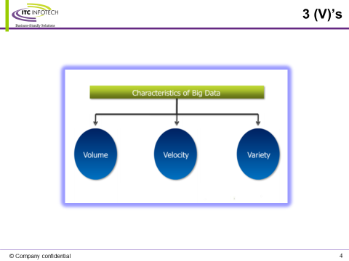

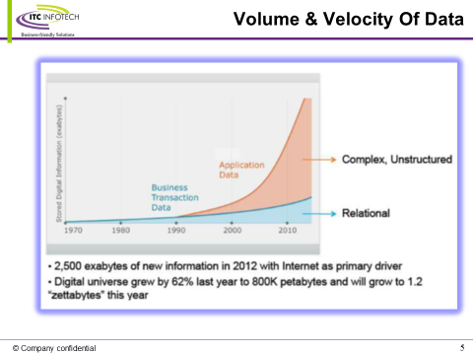

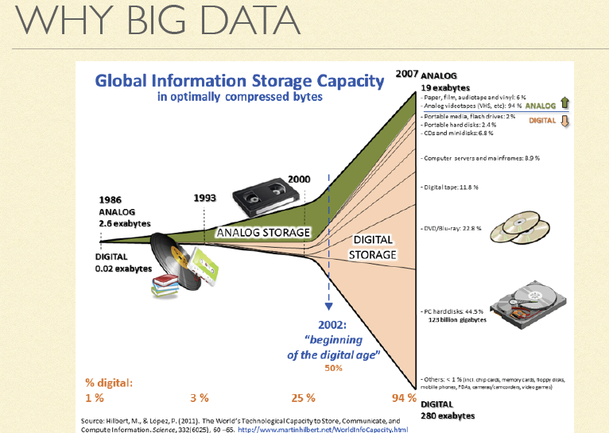



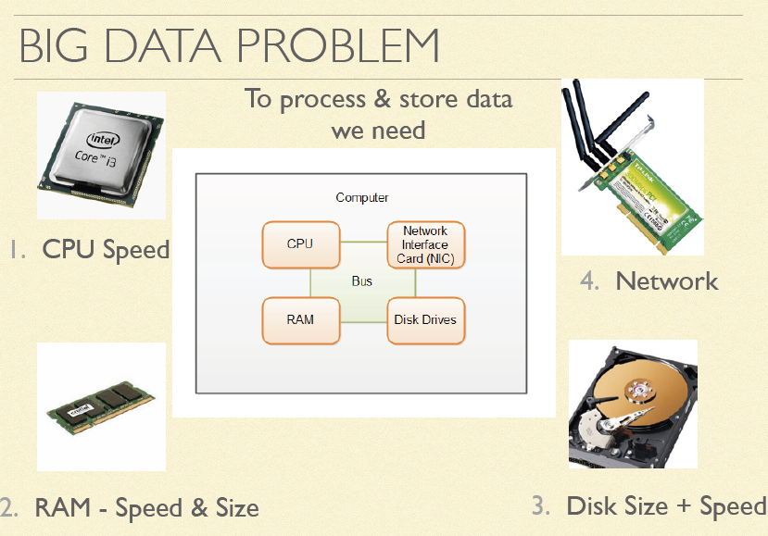









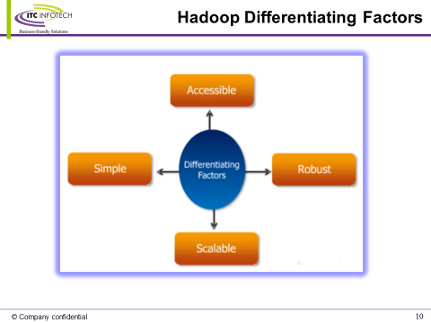

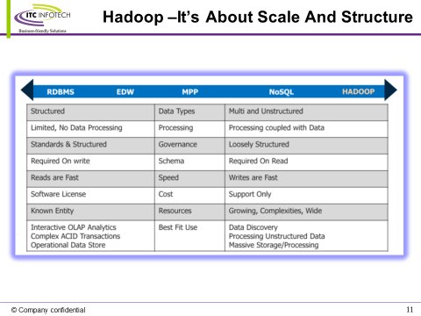



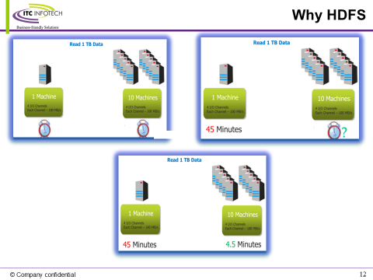

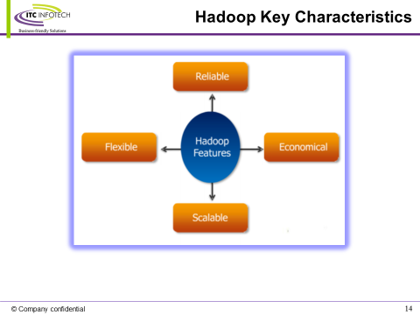

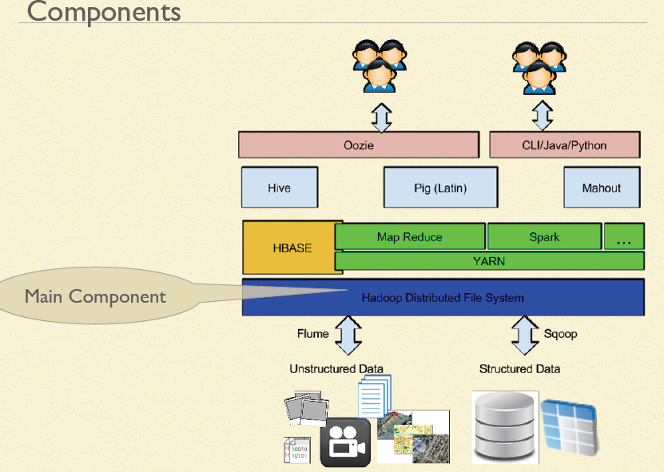

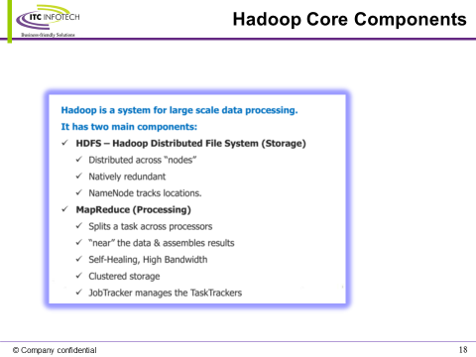

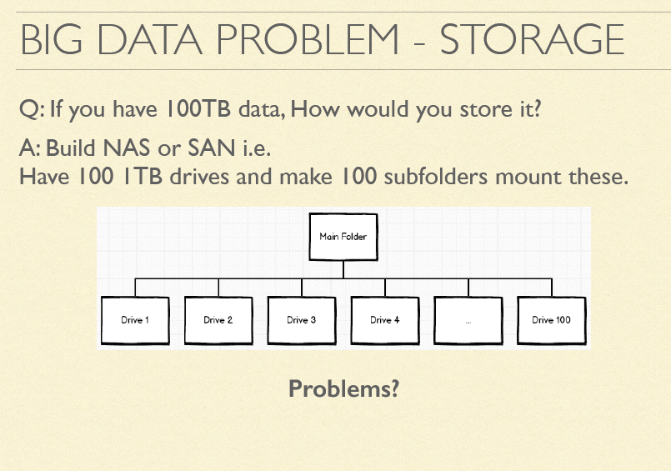

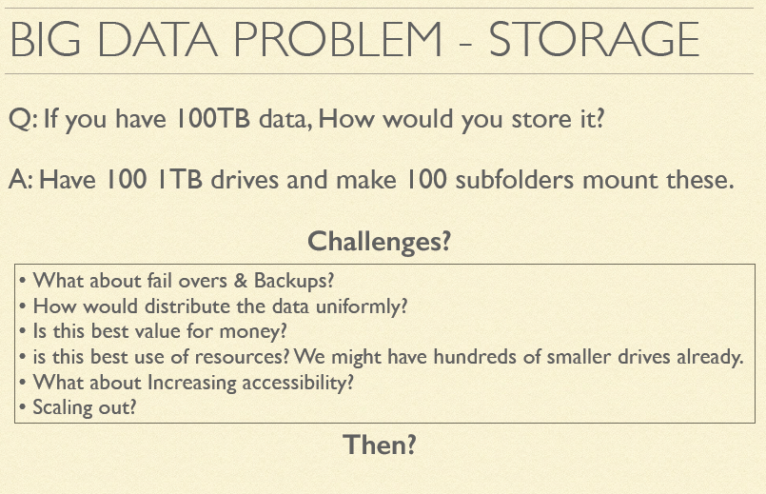

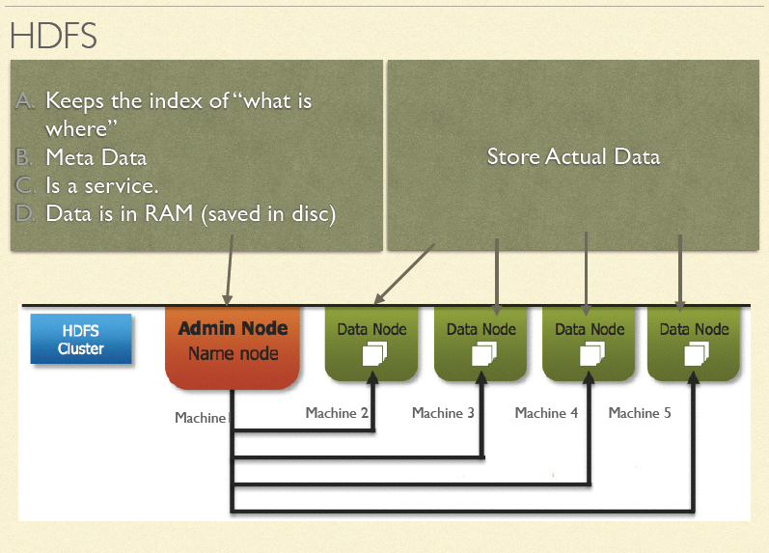

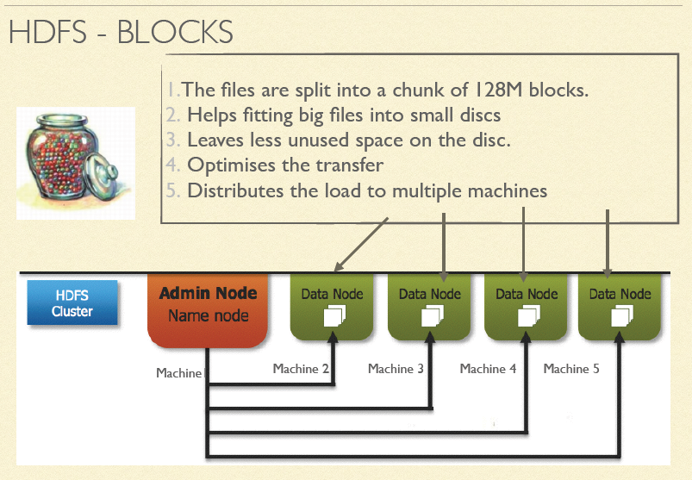

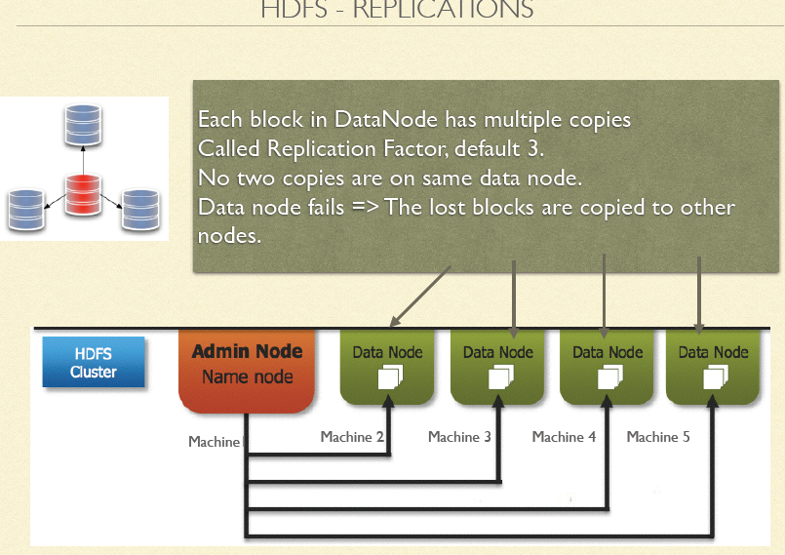

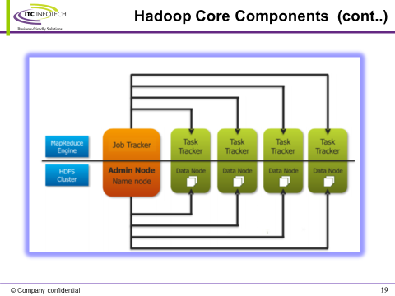

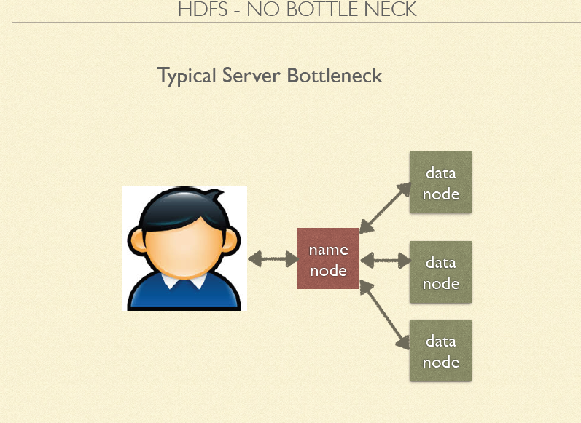

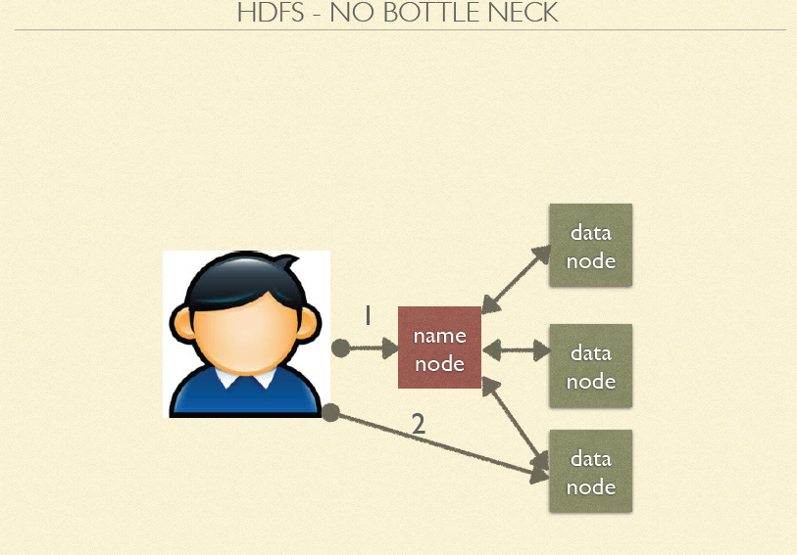

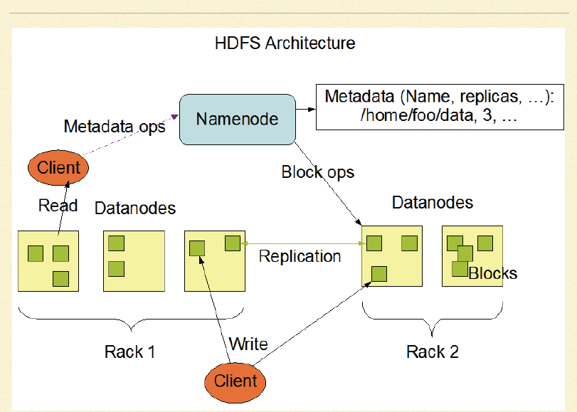

MapReduce1

In versions of Hadoop up to and including the 0.20 release series, mapred.

job.tracker determines the means of execution. If this configuration property is set to

local (the default), the local job runner is used. This runner runs the whole job in a

single JVM. It’s designed for testing and for running MapReduce programs on small

datasets.

Alternatively, if mapred.job.tracker is set to a colon-separated host and port pair, then

the property is interpreted as a jobtracker address, and the runner submits the job to

the jobtracker at that address. The whole process is described in detail in the next

section.

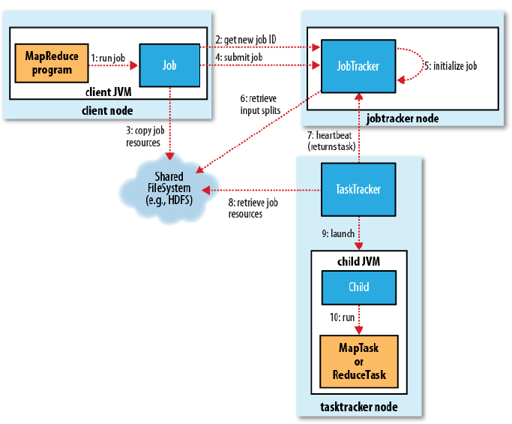

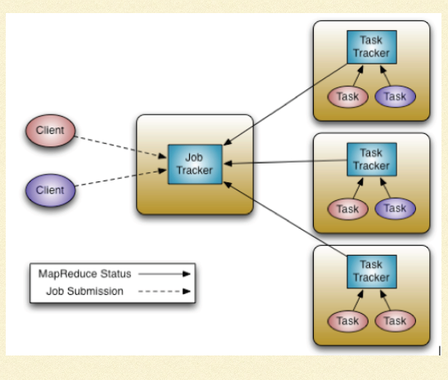

Steps involved in MapReduce1 Job Processing

**Job Submission:**

* Submits the job to the JobTracker and Asks the jobtracker for a new job ID.
* Checks the output specification of the job. For example, if the output directory has not been specified or it already exists, the job is not submitted and an error is thrown to the MapReduce program.
* Computes the input splits for the job. If the splits cannot be computed (because the input paths don’t exist, for example), the job is not submitted and an error is thrown to the MapReduce program.
* Copies the resources needed to run the job, including the job JAR file, the configuration file, and the computed input splits, to the jobtracker’s filesystem in a directory named after the job ID.
* Tells the jobtracker that the job is ready for execution by calling submitJob() on JobTracker.

**Job Initialization:**

* JobTracker puts the job it into an internal queue from where the job scheduler will pick it up and initialize it.
* Job scheduler first retrieves the input splits computed by the client from the shared filesystem . It then creates one map task for each split.
* In addition to the map and reduce tasks, two further tasks are created: a job setup task and a job cleanup task. These are run by tasktrackers and are used to run code to set up the job before any map tasks run, and to cleanup after all the reduce tasks are complete.

**Task assignment:**

* Tasktrackers run a simple loop that periodically sends heartbeat method calls to the jobtracker. Heartbeats tell the jobtracker that a tasktracker is alive, but they also double as a channel for messages.
* Jobtrackert chooses the task from a job based on different scheduling algorithms and assigns the task to the task tracker.
* To choose a reduce task, the jobtracker simply takes the next in its list of yet-to-be-run reduce tasks, since there are no data locality considerations. For a map task, however, it takes into account the tasktracker’s network location and picks a task whose input split is as close as possible to the tasktracker. In the optimal case, the task is datalocal, that is, running on the same node that the split resides on

**Task Execution:**

* Tasktracker localizes the job JAR by copying it from the shared filesystem to the tasktracker’s filesystem.
* it creates a local working directory for the task and “un-jars” the contents of the JAR into this directory.
* it creates an instance of TaskRunner to run the task. TaskRunner launches a new Java Virtual Machine to run each task , so that any bugs in the user-defined map and reduce functions don’t affect the tasktracker

**Job Completion:**

When the jobtracker receives a notification that the last task for a job is complete (this will be the special job cleanup task), it changes the status for the job to “successful. Then, when the Job polls for status, it learns that the job has completed successfully.

YARN (MapReduce 2)

For very large clusters in the region of 4,000 nodes and higher, the MapReduce system

described in the previous section begins to hit scalability bottlenecks, so in 2010 a group

at Yahoo! began to design the next generation of MapReduce.

In Hadoop 2.0, a new MapReduce implementation was introduced. The new implementation

(called MapReduce 2) is built on a system called YARN, The framework that is used for execution is set by the mapreduce.framework.name property, which takes the values 1. In the old MapReduce API, you can call JobClient.submitJob(conf) or JobClient.runJob(conf). local (for the local job runner), classic (for the “classic” MapReduce framework, also called MapReduce 1, which uses a jobtracker and tasktrackers), and yarn (for the new framework).

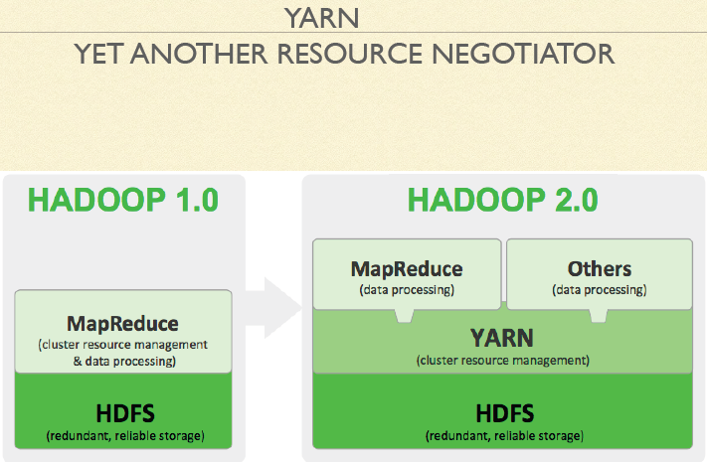

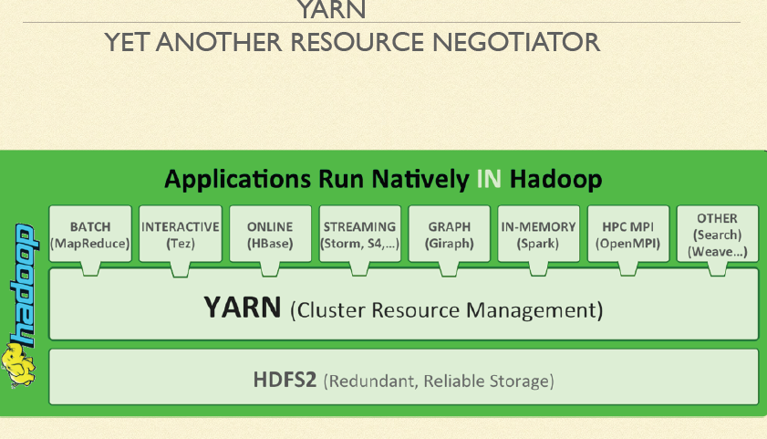

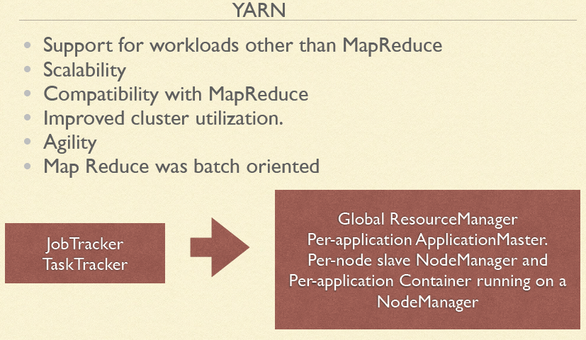



YARN separates JobTracker roles into two independent daemons: a resource manager to manage the use of resources across the cluster and an application master to manage the lifecycle of applications running on the cluster. The idea is that an application master negotiates with the resource manager for cluster resources—described in terms of a number of containers, each with a certain memory limit—and then runs application-specific processes in those containers. The containers are overseen by node managers running on cluster nodes, which ensure that the application does not use more resources than it has been allocated.

**MapReduce on YARN involves more entities than classic MapReduce. They are**

* The client, which submits the MapReduce job.
* The YARN resource manager, which coordinates the allocation of compute resources on the cluster.
* The YARN node managers, which launch and monitor the compute containers on machines in the cluster.
* The MapReduce application master, which coordinates the tasks running the MapReduce job. The application master and the MapReduce tasks run in containers that are scheduled by the resource manager and managed by the node managers.
* The distributed filesystem (normally HDFS, covered in Chapter 3), which is used for sharing job files between the other entities.

**Advantages of YARN:**

* it is even possible for users to run different versions of MapReduce on

the same YARN cluster, which makes the process of upgrading MapReduce more manageable.

* The beauty of YARN’s design is that different YARN applications can coexist on the same cluster—so a MapReduce application can run at the same time as an MPI application, for example—which brings great benefits for manageability and cluster utilization.

